# Title

RC Steady State Simulation

# Objective

To calculate the bandwidth of the network

# Circuit Diagram

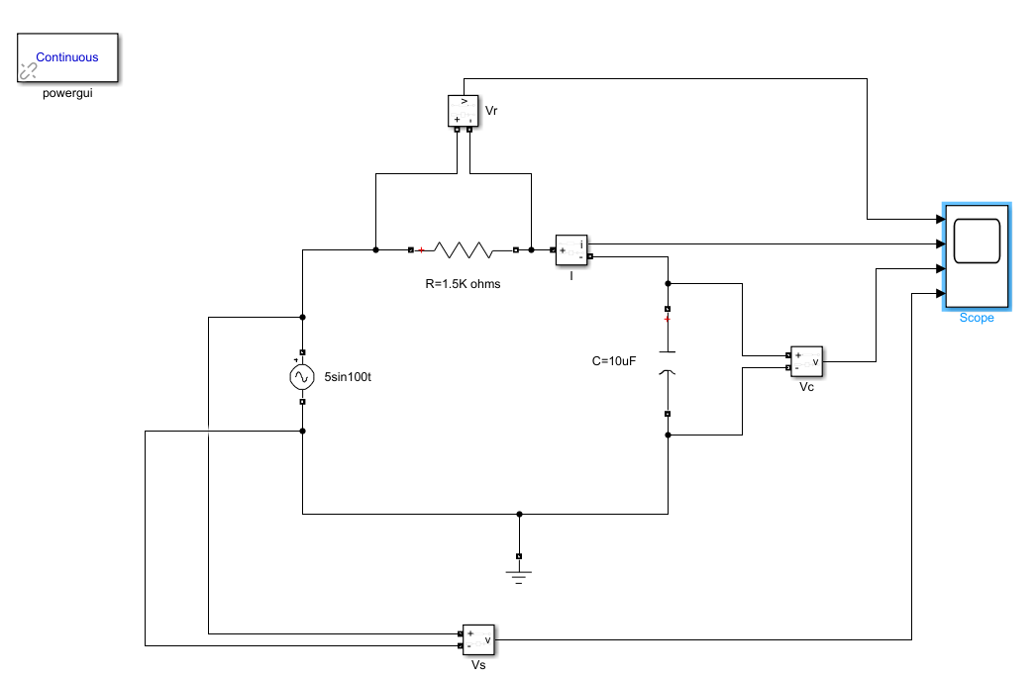

* R = 1500 ohms, C = 10^-5 F
* Time Constant = RC = 0.0150s
* Transfer Function = 1/ (1 + RCs) = 1/(1+0.015s)
* Corner Frequency = 1/0.015 = 66.67rad/s = 10.6 Hz

# Analysis

When we excite the system with a normal frequency of 15Hz we find that almost the entire voltage appears across the capacitor. It doesn’t block any voltage as shown in the figure below.

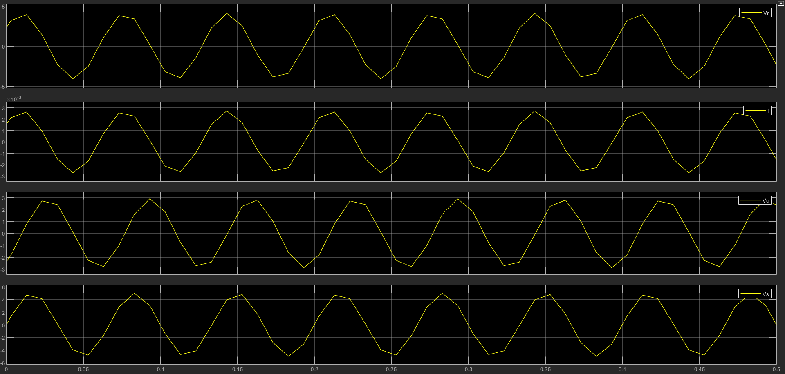

Figure 1: Plot 1 - Vr, Plot 2 - I , Plot 3 - Vc , Plot 4 – Vs (At 15 Hz)

However, as we increase the frequency to (a very high value) we find that no voltage appears across the capacitor. This is because the series RC circuit acts as a low pass filter. It allows lower frequencies to pass through and it blocks higher frequencies.

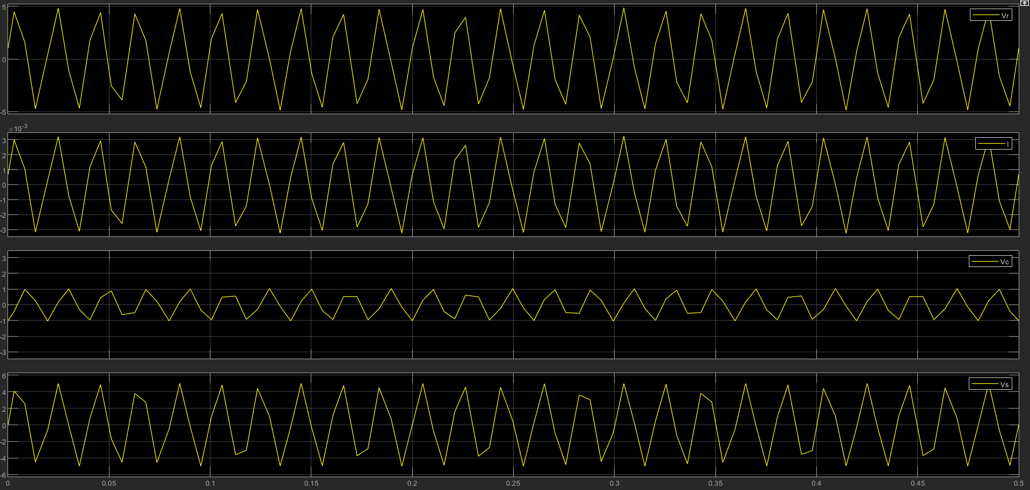

Figure 2: Plot 1 - Vr, Plot 2 - I , Plot 3 - Vc , Plot 4 – Vs ( at 50Hz)

Also, we observe that at very high frequencies almost no output voltage appears across the capacitor as shown in the figure below.

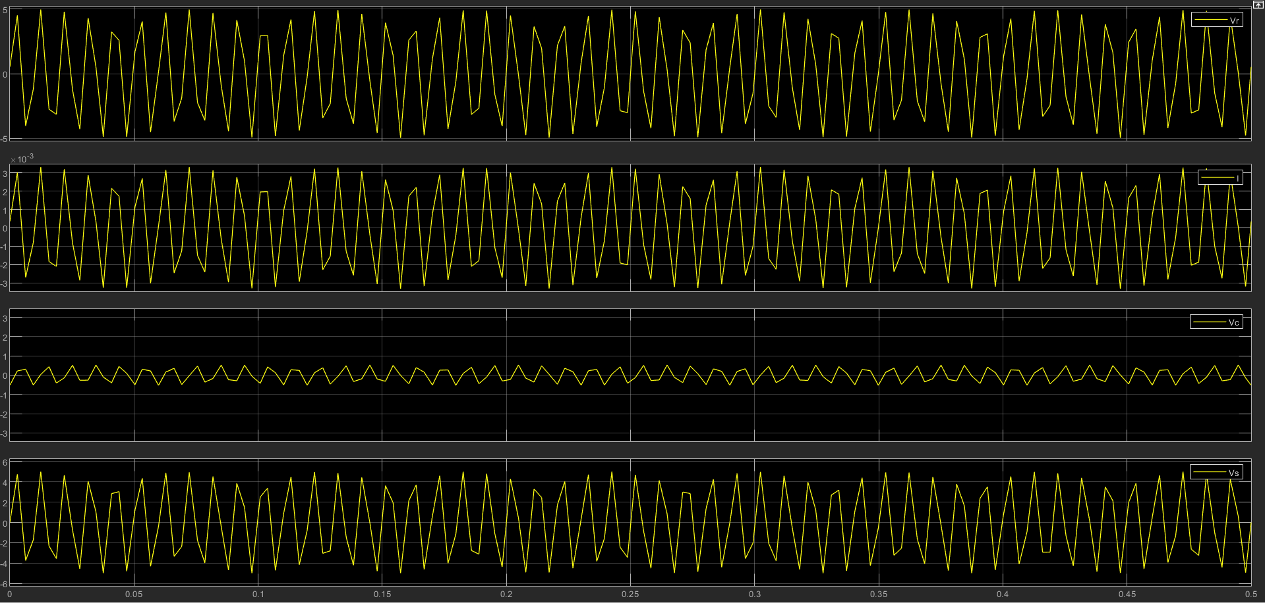

Figure 3: Plot 1 - Vr, Plot 2 - I , Plot 3 - Vc , Plot 4 – Vs ( at 100 Hz )

The exact cut off frequency can be found out from the frequency response of the circuit and drawing a bode plot below.

# Bode Plot

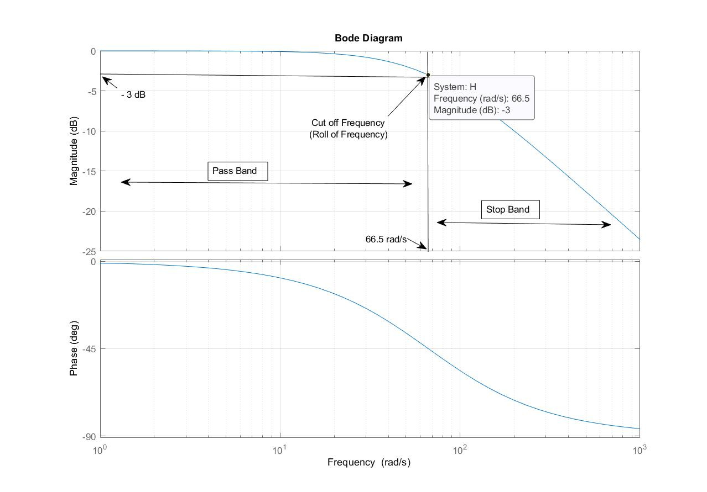As is evident from the plot the -3db gain occurs at 66.5 rad/s. Hence its cut off frequency is 66.5 rad/s = 10.58 Hz. It’s bandwidth is also 10.58 Hz.